# Course work

## Name: Zeng Yuhang

## ID: 222320008

1. Adding equipment

I have added 22 devices as instruction says. The only difference is that the version of Cisco Packet Tracer is so low that it does not contain Cisco 1941 Router. I substitute it by 1841 Router. There is no much difference between two kinds of router in this task except for the commands used to connect the departments.

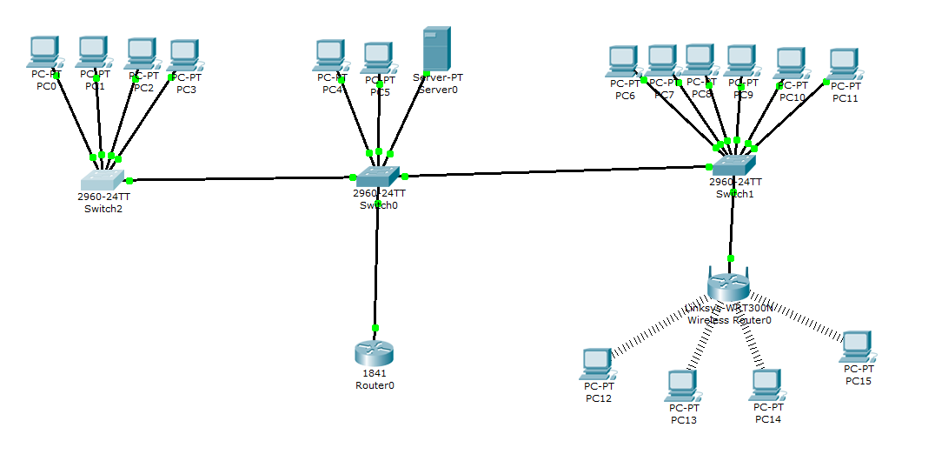

1. Installing the Wi-Fi module in the PC

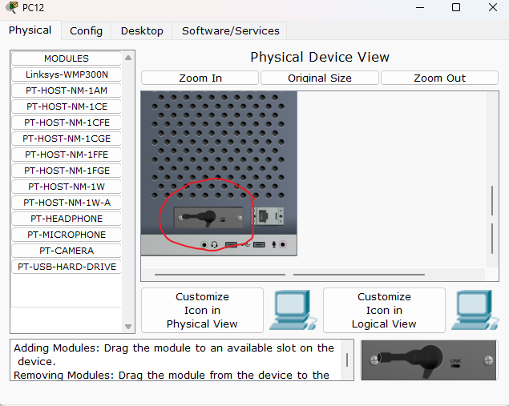

In order to make PC12-15 be able to connect to Wi-Fi, we need to change the physical device of the machines. The device in the red circle is the part to connect the PC to network. It is initialed like . I firstly drag it off the machine, and then put the WMP300N to the right position. To emphasize, the operations described above can be done only if the device is showdown by clicking the red button like  to make the green light switched off.

1. Setting up the PCs of the first and second departments

Set IP Address, Subnet Mask, Default Gateway and DNS Server exactly as instruction says. Below are the examples.

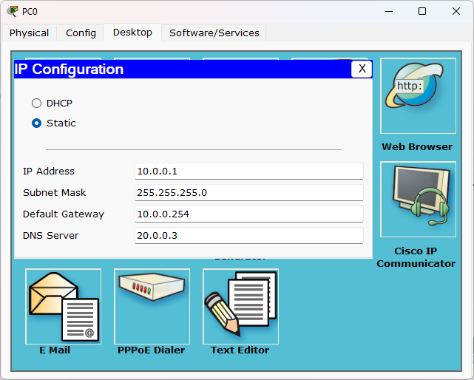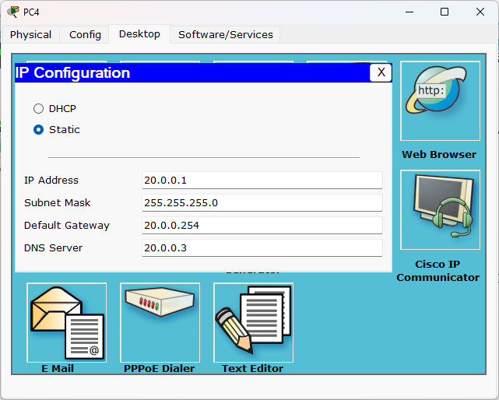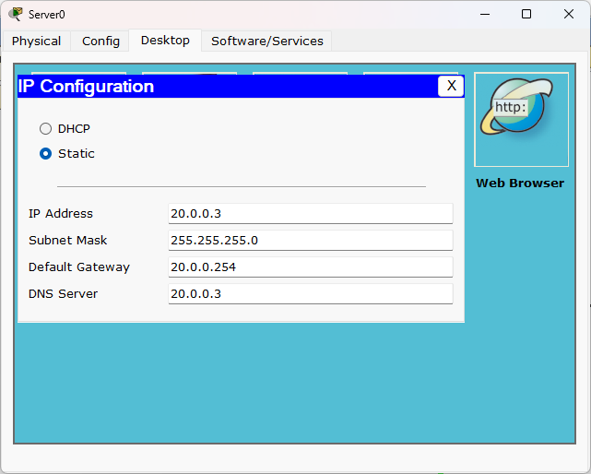

1. Setting up the third department

The IP set of third department is a little different from others of two department. The PCs connect to Wireless Router do not have inference FastEthernet. Instead, we need to config the IP address which is set DHCP as default in inference Wireless. Below are examples.

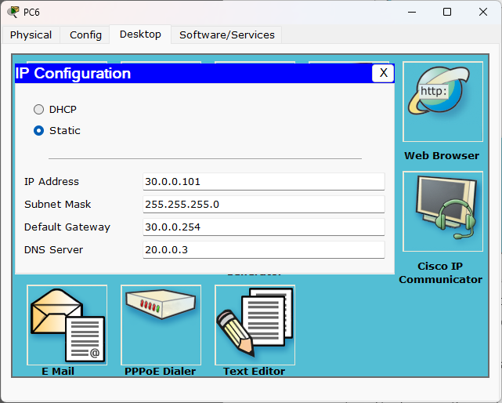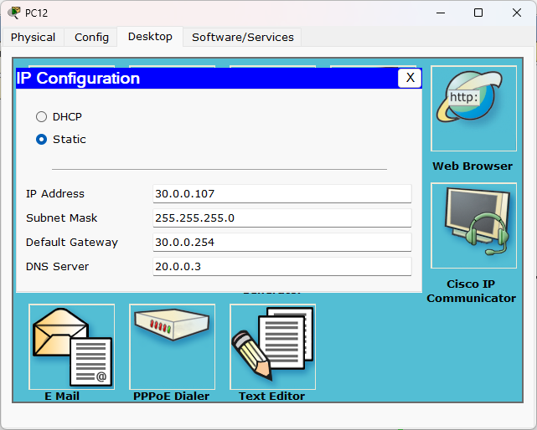

1. Configuring the router

After following the instruction rightly, there will appear connection lines similar to Wi-Fi signal.

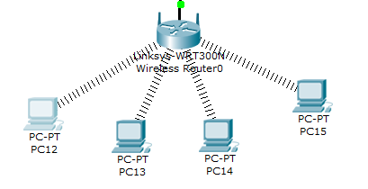

1. Connect the cables and connect the departments

Connect the cables using Copper Straight-Through.

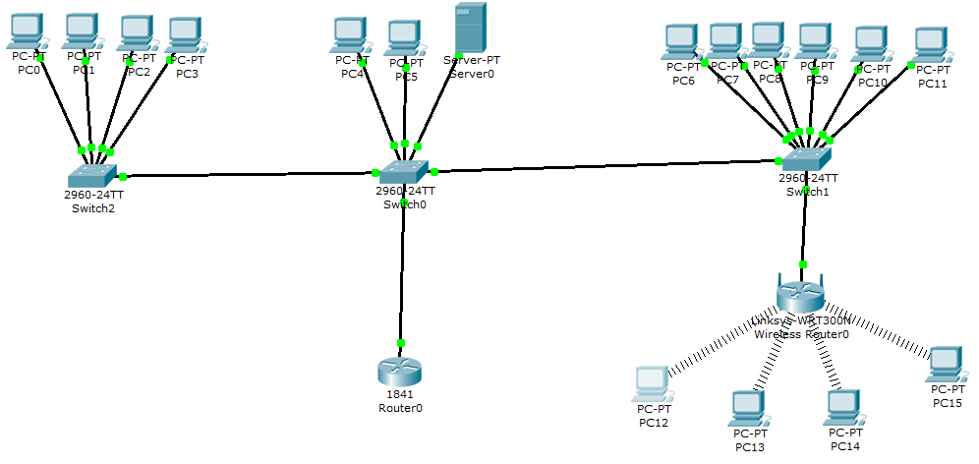

Then, follow the instruction to create 4 different VLANs. And set the right VLAN in the inferences of each switch. Specially, the inference connects switch and router needs to be set to Trunk mode so that messages from all VLANs can be transferred to the router. We also need to create sub inference for router because messages from all VLANs will send to the same inference in this task. We distinguish different VLAN using different sub inference.

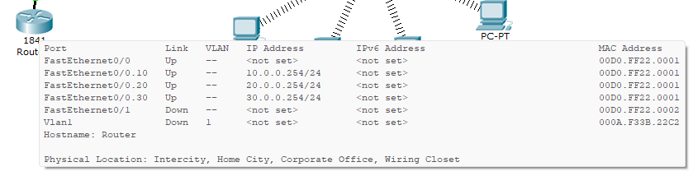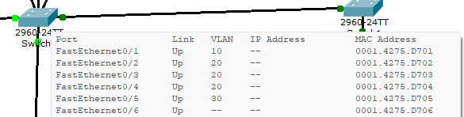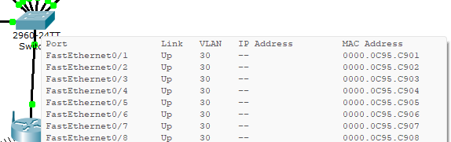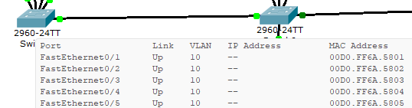

The ping results are showing below.

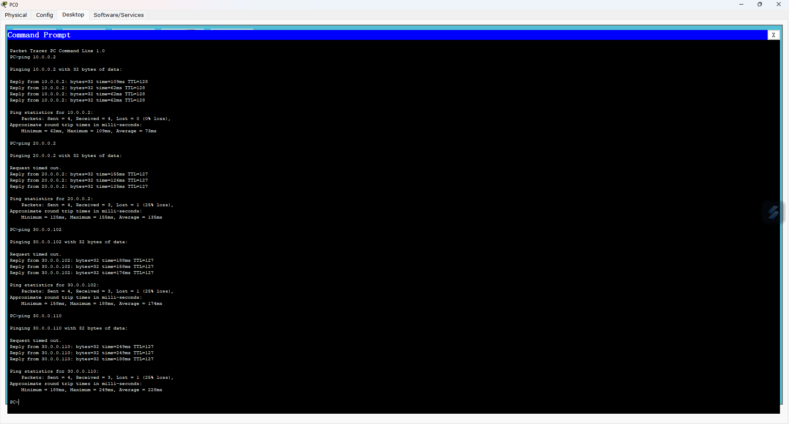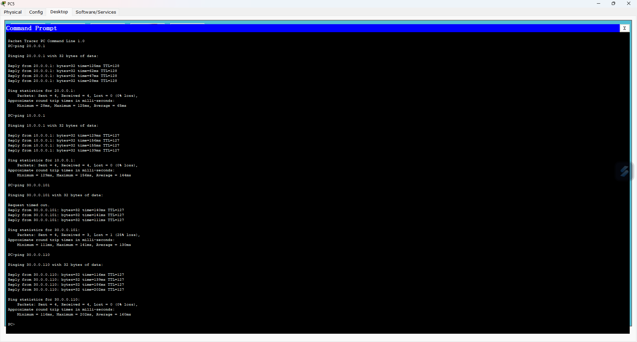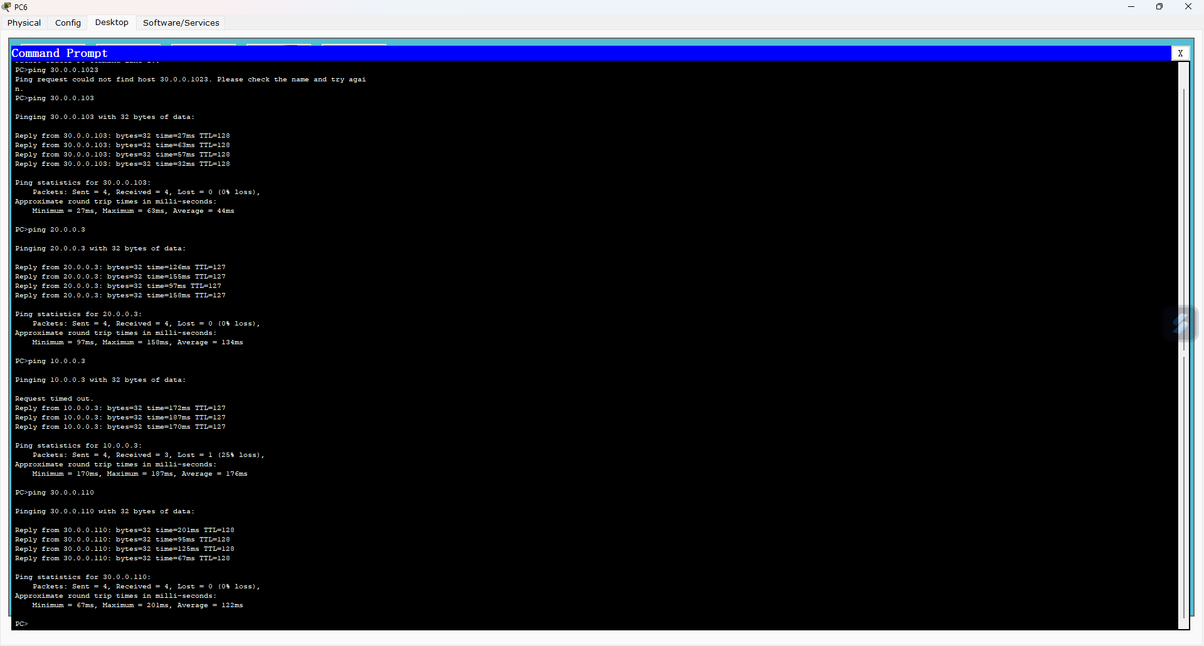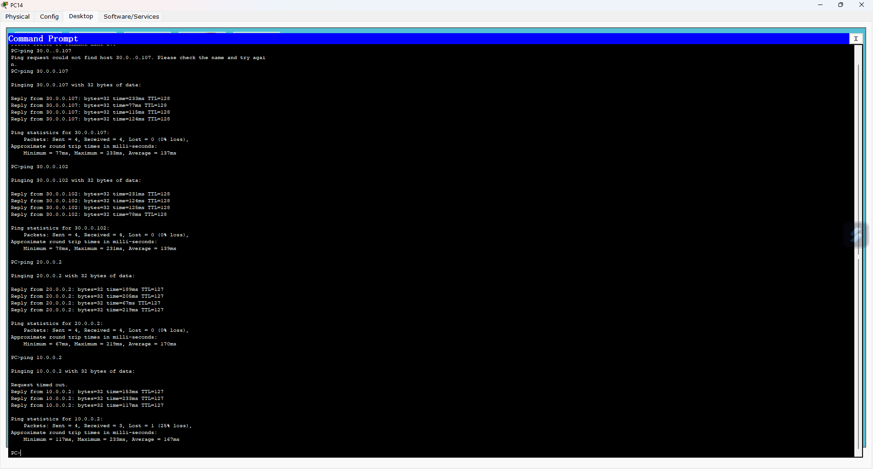

1. Server setup

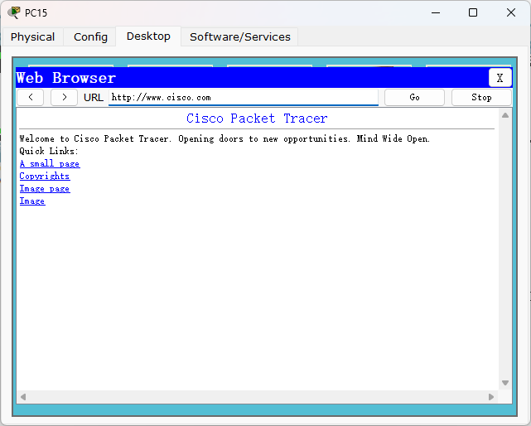

1. Configure SSH
2. Configure the protection against on each switch

final result:

